 ,,

**Customer Requirements Specifications (CRS)**

***Commercial Module***

# **Document Information**

|  |  |
| --- | --- |
| Document Name | Commercial Management for Samuda Chemicals Ltd. (CRS) |
| Document Author | Kamrun Nahar |
| Document Version | 1.0 |
| Release Date |  |

|  |  |
| --- | --- |
| Review by | Md. Mahfuzur Rahman |
| Review Date | TBA |
| Approved By | Matiar Rahman |
| Approval Date | TBA |

Signed on behalf of Signed on behalf of

Samuda Chemicals Ltd. Genweb2 Limited

Name: Name:

Designation: Designation:

Date: Date:

**______________________________ ______________________________**

Signature Signature

# **Document History**

|  |  |  |  |  |  |
| --- | --- | --- | --- | --- | --- |
| A=Added, M=Modified, D=Delete | | | | | |
| **Version No** | **Date** | **Section No** | **A/M/D** | **Description of Change** | **Author** |
| 1.0 | 28-Jan-2017 |  | A | Initial | Kamrun Nahar |
|  |  |  |  |  |  |
|  |  |  |  |  |  |

Contents

**A.** **Document Information** 2

**B.** **Document History** 3

**1.0** **Introduction** 5

**1.1 Purpose of CRS** 5

**2.0** **Commercial Module Overview** 5

**3.0** **Commercial Module and its Process** 7

3.1 Techno-Commercial Process 8

3.1.1 Process Flow Description 9

3.2 Purchase Order (PO) Approval Process 10

3.3.1 Process Flow Description 11

3.3 Quotation Approval Process 11

3.3.1 Process Flow Description 11

3.3 Letter of Credit (LC) Process 12

3.2.1 Process Flow Description 12

3.3 Telegraphic Transfer (TT) Process (fig change) 13

3.2.1 Process Flow Description 13

3.5 Goods Delivery Process: (fig change) 14

3.4.1 Process Flow Description 14

3.5 Goods Receive Process (fig change) 15

3.5.1 Process Flow Description 15

3.6 Other Major Functionalities 15

3.6.1 Process Flow Description 15

**4. Appendix** 17

**5. To be Determined** 34

# **Introduction**

# **1.1 Purpose of CRS**

The purposes of this CRS (Customer Requirement Specification) are to clearly identify the customer requirements and provide a detailed document. The customer will review the document and approve/make changes as required. It will also help the review team to validate whether the customer requirements have been fulfilled or not.

# **Commercial Module Overview**

Globalization has encouraged many establishments to shift business focus beyond geographic boundaries as a way to increase their top line reviews. Subsequently, the imports/exports have boomed. However, importers/exporters are facing a problem with customers spread across different geographical locations, making it tough for them to comply with different export/import rules and regulations. Without a proper import /export management system, exporters/importers are unable to screen potential customers/supplier to see if they are listed on the restricted party list, figure out license requirements, comply with export rules and statutory regulations and generate the required import/export documentation.

Our versatile and robust Commercial management system will make it easy for the business to handle even the smallest import/export-related task. Our module is designed to automate import/export compliance and transactional functions; using it authorized user can deal with required international supplier/customer, ensure smooth delivery/receive process, generate necessary documents and file. In addition, this system also allows to maintain audit trails and promote management reporting. It is efficient and helps the business to make import/export process more efficient, while reducing the chances of risks.

Domestic sales procedure and international sales procedure is different thing in any organization. Commercial module works for resolving the issues where Buyers and Sellers are from different countries and they need to be assured about the product and payment. Commercial (Export & Import) module handles all the internationally accepted procedures to make sure successful international sales and purchase. Now a days some procedures like LC (Letter of Credit) became popular for domestic sales also, Commercial module will be managing all this scenario to make the import/export profitable one.

**Importance of Commercial Module**

It is user-friendly and has an easy interface. It is one of the easiest module which will serve business needs of commercial parts. User can customize different elements of the application. Using our export management system, you will be able to reduce the time and effort it takes to be current with regulations and lists, manage all export documentation effortlessly and ensures information are up-to-date. Using this module, it will reduce stress of losing the ability to export, as it will allow you to comply with all statutory regulations comfortably.

The solution is proposed to efficiently maintain and track the operational records starting from purchasing to final delivery. It is highly functional to which customers’ expectations and vendor delivery requirements get conveniently met simultaneously. Almost all the importers and exporters are facing problem in managing goods transaction related options for the elimination of these issues, so this is module gives a solution that best suited with import and export business needs.

# **Commercial Module and its Process**

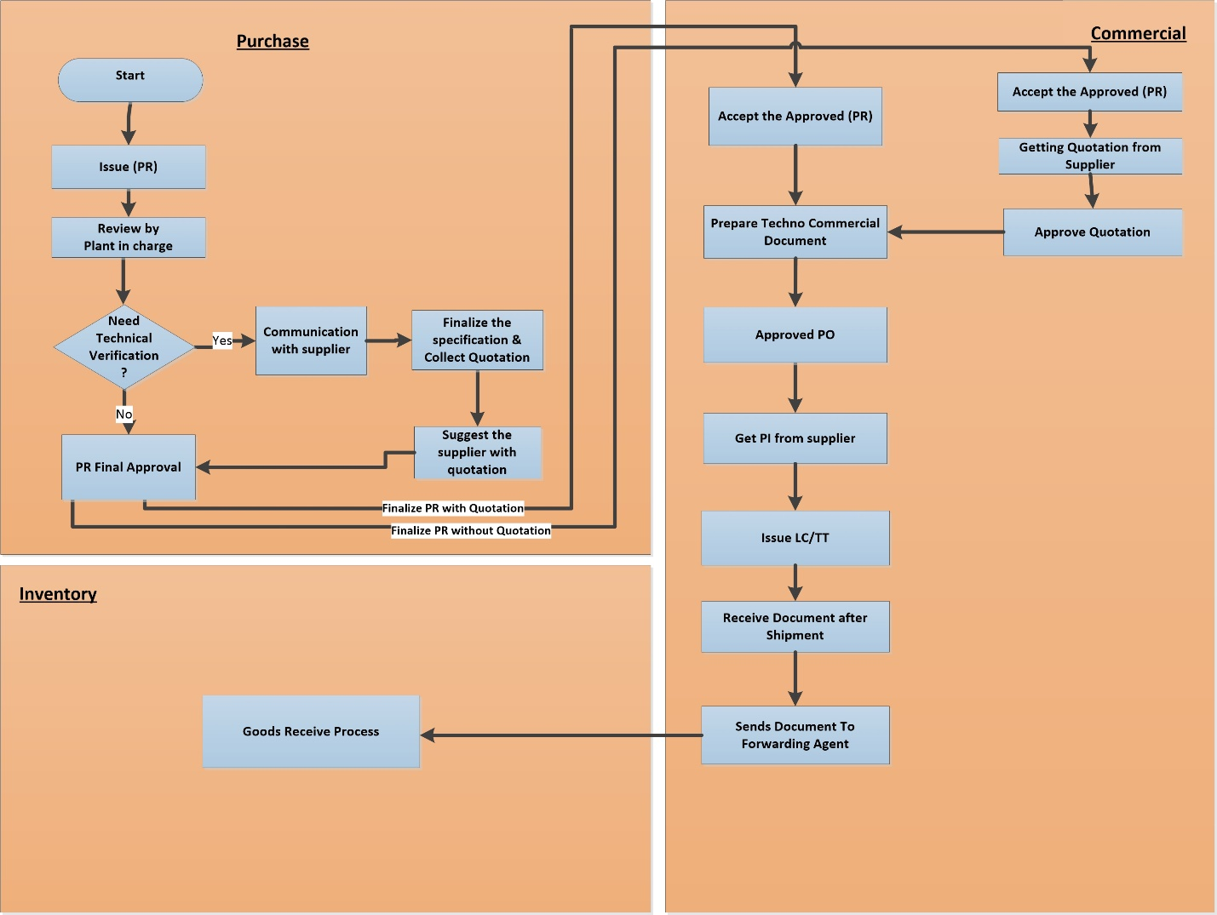

**Fig:** Comprehensive Commercial Process

The Following are the Sub-Processes of commercial module:

1. Techno Commercial Process
2. Purchase Order (PO) Approval Process
3. Quotation Approval Process
4. LC Process
5. TT Process
6. Account Module Integration(Pending From customer)
7. Goods Receive Process

## Techno-Commercial Process

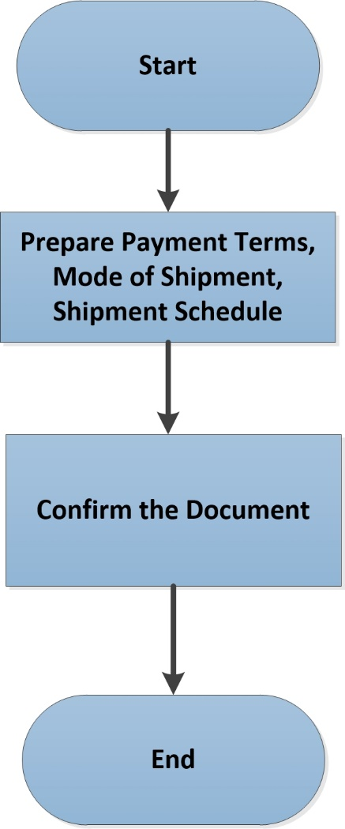

**Fig:** Techno-Commercial Process

### 3.1.1 Process Flow Description

* 1. After approval of purchase requisition commercial department start preparing for techno-commercial document which is both for raw material and machinery items.
  2. After taking all the approval, commercial department sends the quotation to selected supplier/vendor all over the world.
     1. Buyer may be selected depends on good quality, quantity or price etc.
  3. Commercial department prepares a techno-commercial documents which includes mode of shipment, payment terms, shipment schedule etc.
  4. After that all the document will be confirmed by authorized personnel.

## 3.2 Purchase Order (PO) Approval Process

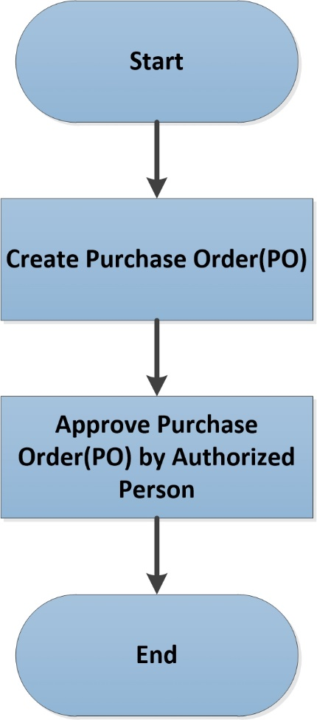

**Fig:** Purchase Order (PO) Approval Process

### Process Flow Description

1. Authorized user/department will create Purchase Order (PO) against the Purchase Requisition (PR). One PR can have multiple PO.
2. Once vendor is selected Authorized user/department starts processing on purchase order (PO).
3. Purchase Order (PO) will have its unique order number, specific terms and conditions, supplier and consignee information etc.
4. This purchase order now may go through one or two approval layer based upon value or quantity or product.
5. The Purchase Order PO and Purchase Requisition (PR) approver will have to be the same person.
6. Once all the approval processes are complete then the PO is given to the vendor.

## Quotation Approval Process

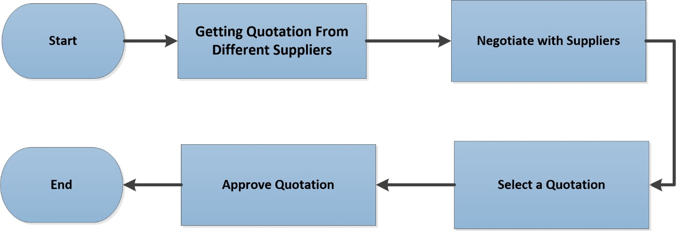

**Fig:** Quotation Approval Process

### Process Flow Description

1. Authorized user/department receives Quotation which was sent by supplier with details specification of materials/products and make negotiation with suppliers.
2. Authorized user/department request to Authorized Manager for the selection of quotation depending on received purchased requisition.
3. Authorized Manager receives the Request and approve the quotation. If they reject it, process will end there.
4. After getting Selection confirmation from Procurement Manager, Procurement Executive creates Purchase Order (PO).

## Letter of Credit (LC) Process

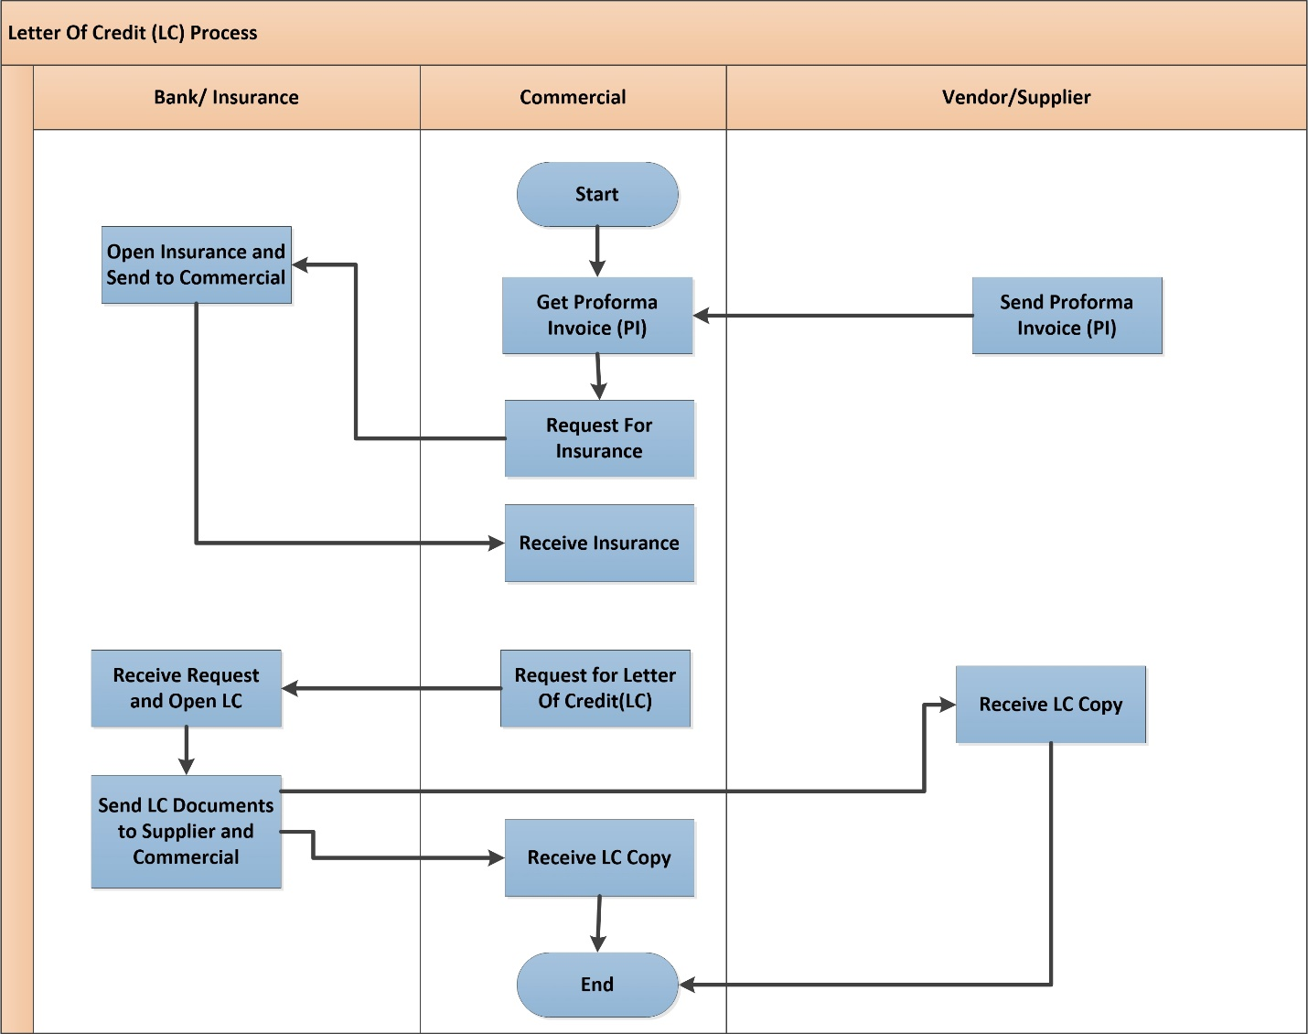

**Fig:** Letter of Credit (LC) Process

### Process Flow Description

1. Buyer and seller agree to conduct business. The seller wants a letter of credit to guarantee payment.
2. Buyer applies to his bank for a letter of credit in favor of the seller.
3. Buyer's bank approves the credit risk of the buyer, issues and forwards the credit to its correspondent bank (advising or confirming). The correspondent bank is usually located in the same geographical location as the seller (beneficiary).
4. Advising bank will authenticate the credit and forward the original credit to the seller (beneficiary).
5. Seller (beneficiary) ships the goods, then verifies and develops the documentary requirements to support the letter of credit. Documentary requirements may vary greatly depending on the perceived risk involved in dealing with a particular company.
6. Seller presents the required documents to the advising or confirming bank to be processed for payment.
7. Advising or confirming bank examines the documents for compliance with the terms and conditions of the letter of credit.
8. If the documents are correct, the advising or confirming bank will claim the funds by:   
   - Debiting the account of the issuing bank.  
   - Waiting until the issuing bank remits, after receiving the documents.  
   - Reimburse on another bank as required in the credit.
9. Advising or confirming bank will forward the documents to the issuing bank.
10. Issuing bank will examine the documents for compliance. If they are in order, the issuing bank will debit the buyer's account.
11. Issuing bank then forwards the documents to the buyer.
12. One Proforma Invoice (PI) will issue one Letter of Credit (LC) only.

## Telegraphic Transfer (TT) Process (fig change)

### Process Flow Description

1. Samuda sometimes use TT for emergency purpose or small amount of TT.
2. T/T stands for telegraphic transfer, a form of bank transfer. TT payments are cheap and fast way of transferring money overseas through most banks.
3. Bank transfers (also known as telegraphic transfers or TT) is one of the simplest forms of international transfers. In traditional international trade, it’s risky for buyers to pay using bank transfers because their money goes into the suppliers’ bank account directly - before they are able to receive their order.
4. TT, Telegraphic Transfer of money was effected by a cable message service from one bank to another to transfer money. TT payment was very popular prior to existence of electronic payment networks. Telegraphic transfer is operated by cable message and TT is treated one of the other electronic fund transfers.
5. While payment done on TT, buyer should remember certain things in their mind such as (get the beneficiary name, address and other account details right, the right company name, pay all the bank transaction fees including beneficiary bank fees, save a transaction record and send it to supplier etc.)

## Goods Delivery Process: (fig change)

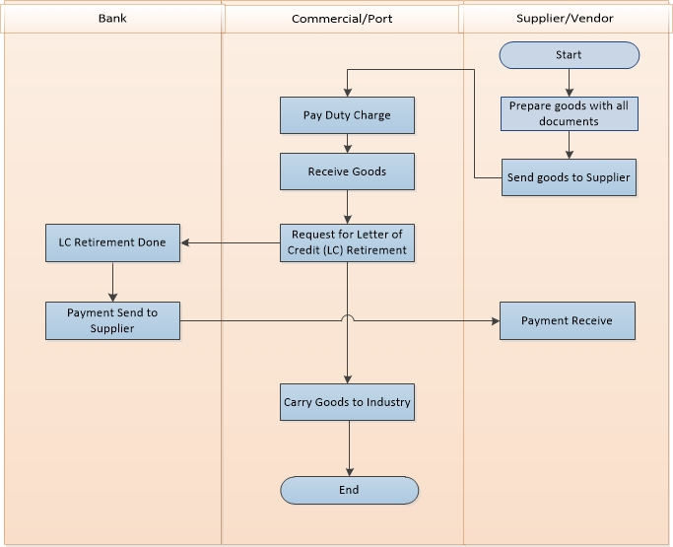

**Fig:** Goods Delivery Process

### 3.4.1 Process Flow Description

* 1. Supplier prepares the goods and make it ready for shipping the goods including all documents. Documents required for delivering goods are given below-
     1. **Shipping Documents:** Air waybill, bill of lading, or truck bill of lading, commercial invoice, certificate of origin, insurance certificate, packing list, or other documents required to clear customs and take delivery of the goods.
     2. **Customer Invoice:** A document, required by some foreign countries' customs officials to verify the value, quantity, and nature of the shipment, describing the shipment of goods and showing information such as the consignor, consignee and value of the shipment.
     3. **Port Clearance:** After receiving the documents of title of the goods, the importer’s only concern is to take delivery of the goods, when the ship arrives at the port and to bring them to his own place of business. The importer has to comply with many formalities for taking delivery of goods. Unless the following mentioned formalities are complied with, the goods lie in the custody of the Custom House.
  2. Supplier sends goods to customer according to mentioned route which was written in documents.
  3. Commercial receives goods by paying all for documents and charges to port.
  4. After completed all formality, commercial receives goods and place an LC retirement request to LC issuing Bank.
  5. Commercial sends the goods in mentioned delivery address.

## Goods Receive Process (fig change)

### 3.5.1 Process Flow Description

* 1. Industry receives all goods by preparing a Material Receiving Repot (MRR).
  2. In MRR, customer includes all product description with quantity, purchase order no., packing no. and vat if any.
  3. There is MRR approval hierarchy which is given below-

1. Quantity Receive by –> Sign & Designation
2. Received by -> Store Personnel
3. Approved by -> Plant-in-charge

## 3.6 Other Major Functionalities

### 3.6.1 Process Flow Description

1. After approval of purchase requisition commercial department start preparing for techno-commercial document which is both for raw material and machinery items.
2. After taking all the approval, commercial department sends the quotation to selected supplier/vendor all over the world.
   * 1. Buyer may be selected depends on good quality, quantity or price etc.
3. Commercial department prepares a techno-commercial documents which includes mode of shipment, payment terms, shipment schedule etc.
4. After that commercial module will issue purchase order (PO) and it will have its required approval process.
5. Commercial department receives multiple Proforma Invoices (PI) from multiple suppliers.
6. Commercial department selects one of multiple Proforma Invoices depending on price, quantity and other factors. After the selection of Proforma Invoices (PI), negotiation starts with the selected supplier. Negotiation may include price, quantity, delivery time etc.
7. After negotiation, commercial department may select one or multiple vendors for particular order. The supplier selection can be two types.
8. Select one supplier for regular purchase
9. Select multiple suppliers if one supplier is unable to supply the goods for their customer.
10. After final negotiation with supplier, commercial department issue LC/TT.
11. All negotiation must be discussed through email and will be used as supporting documents for delivering/receiving goods.

# **4. Appendix**

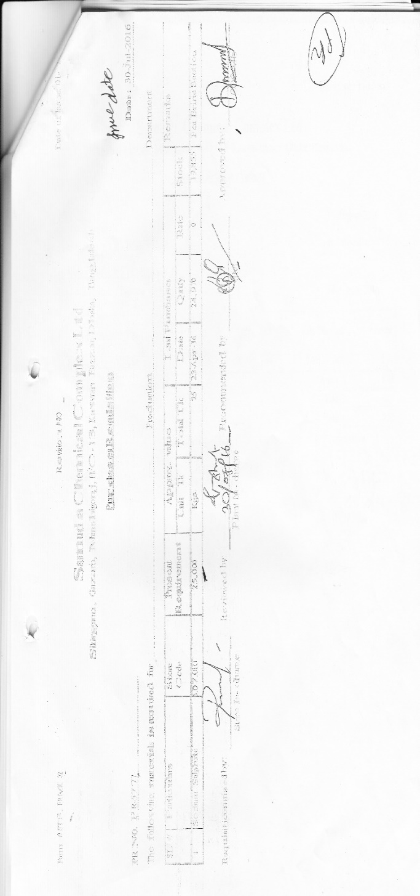

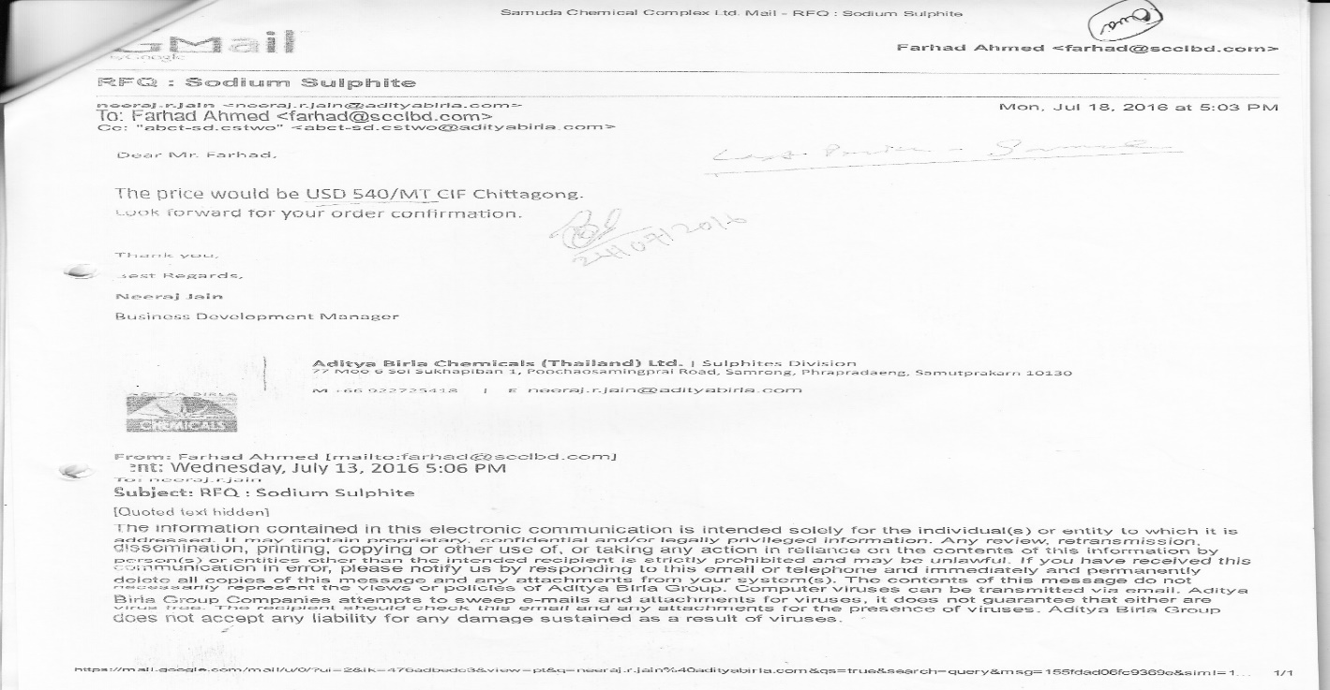

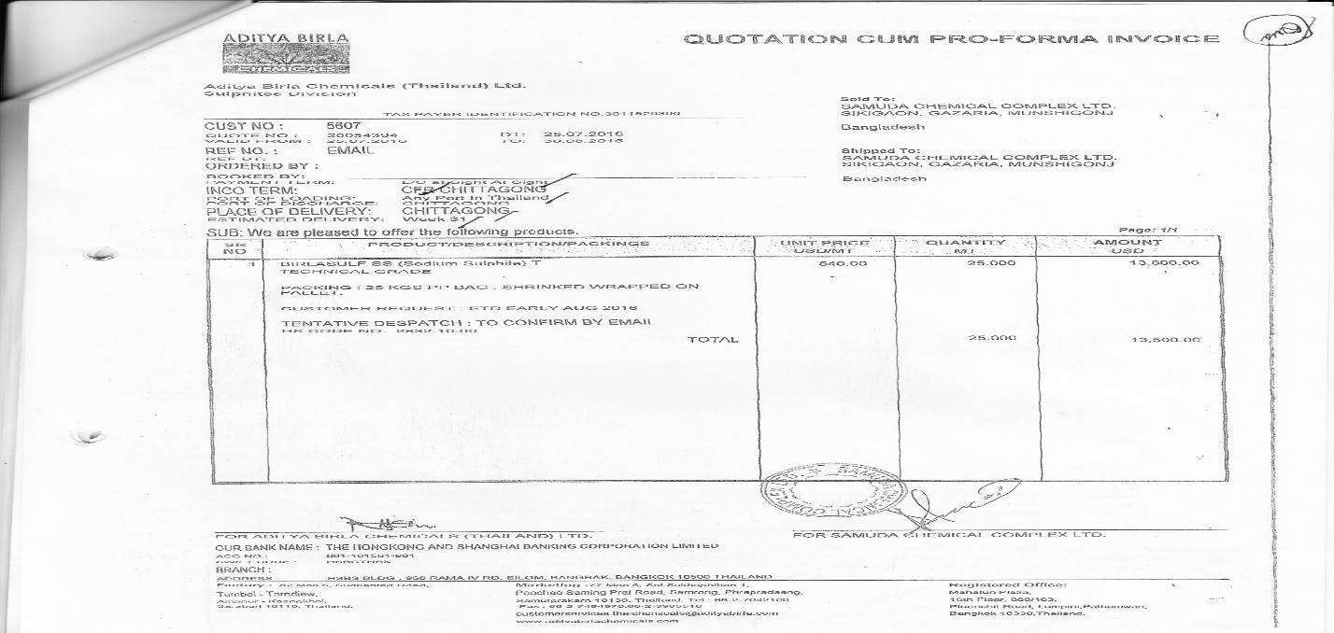

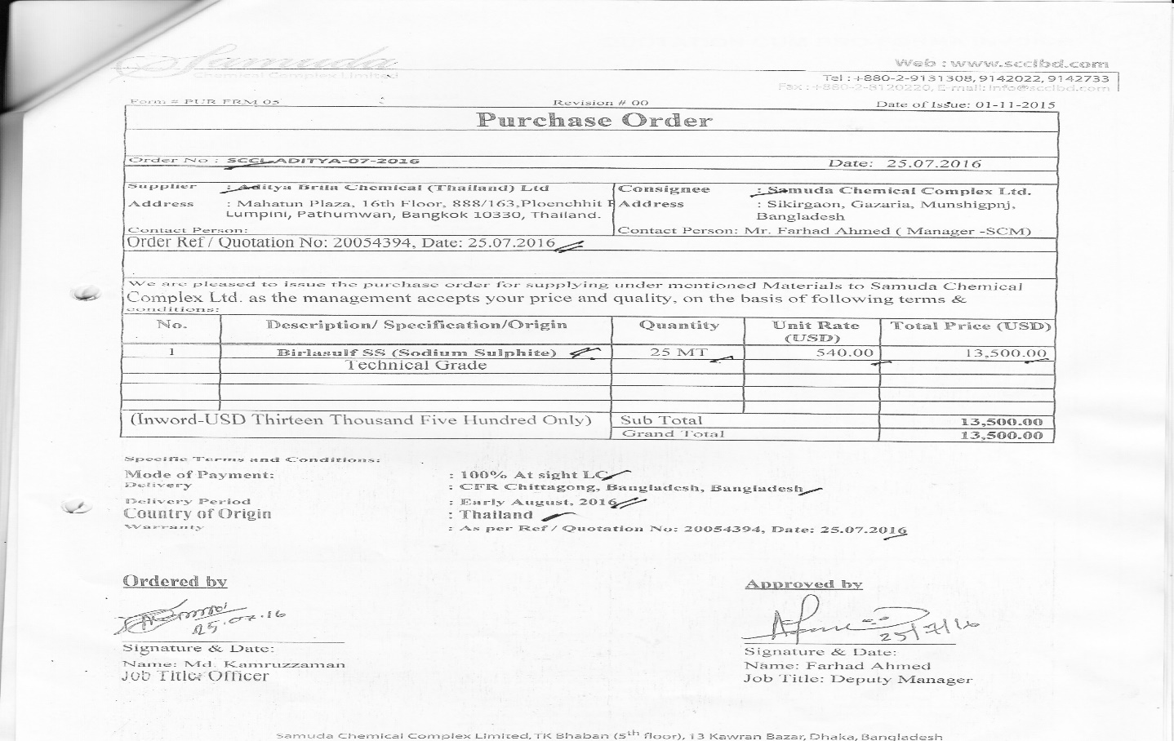

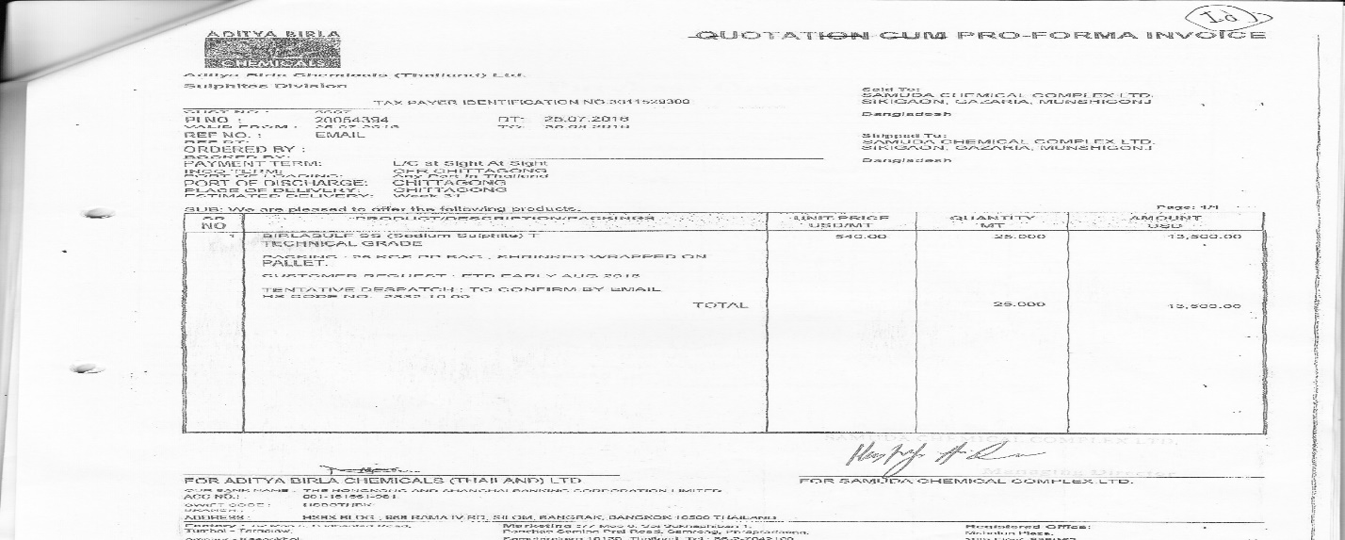

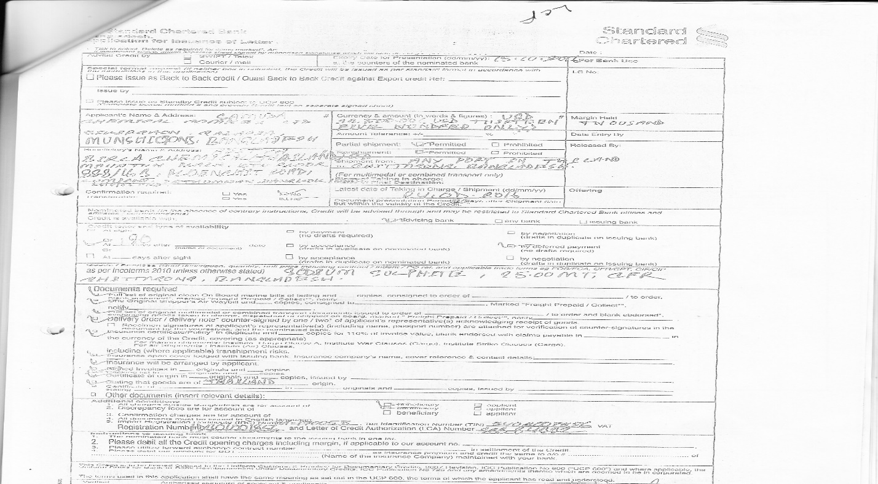

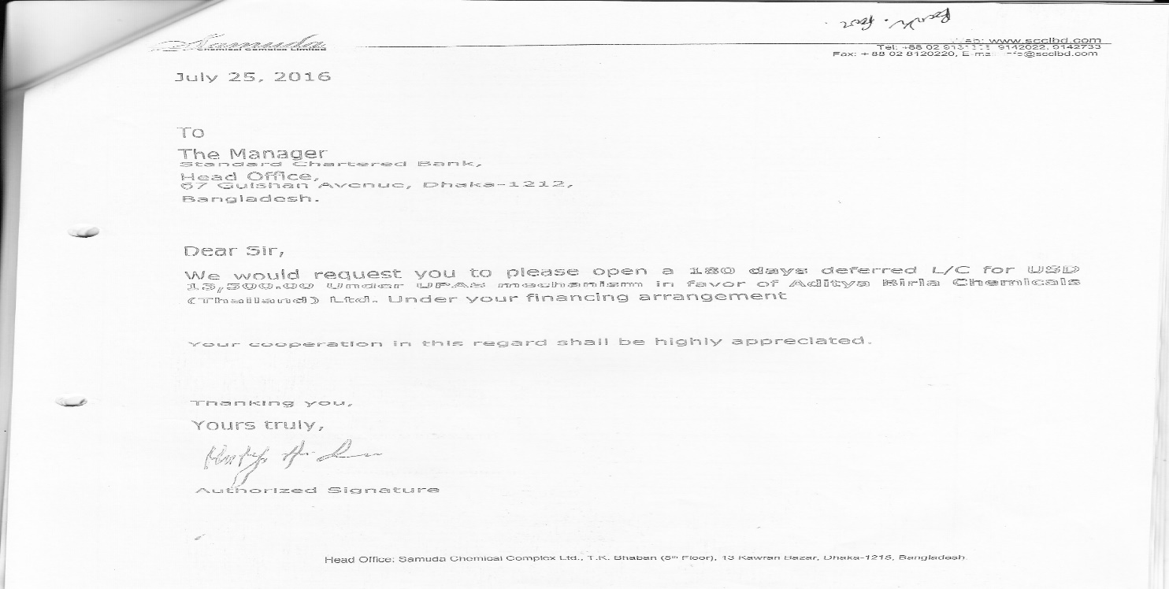

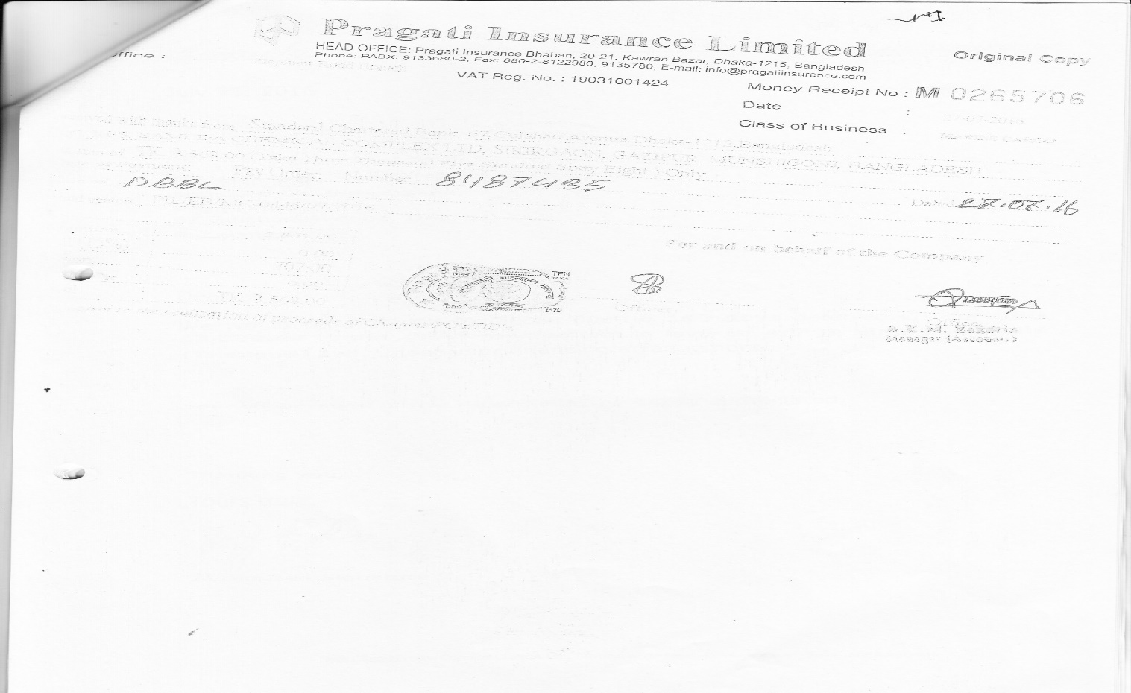

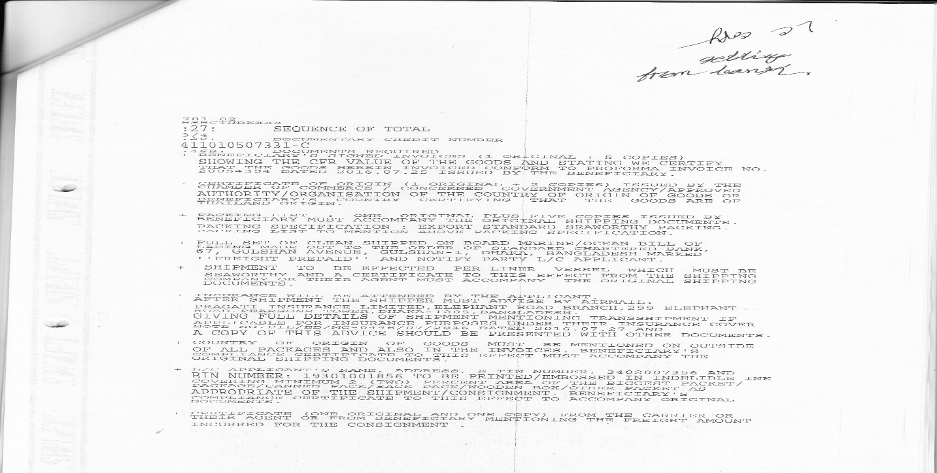

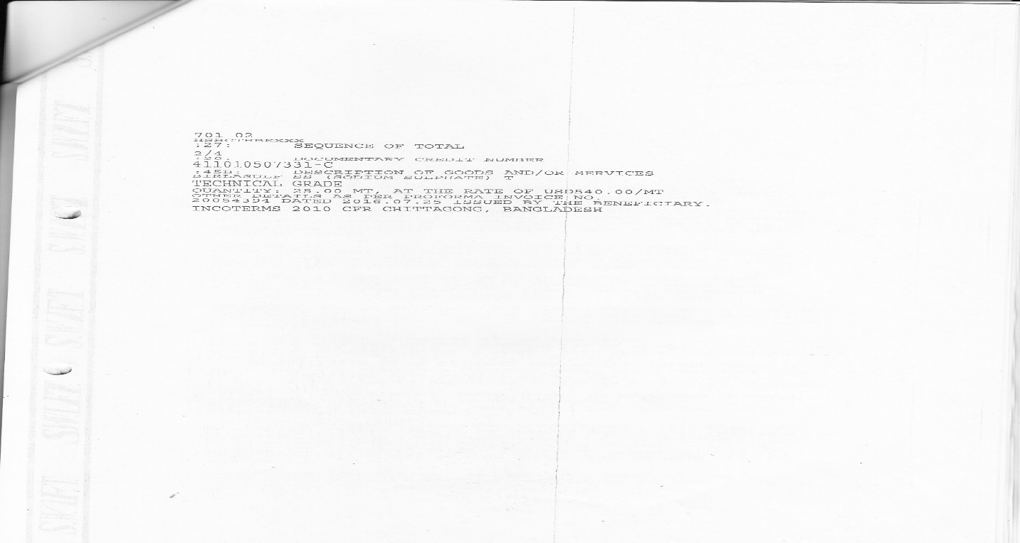

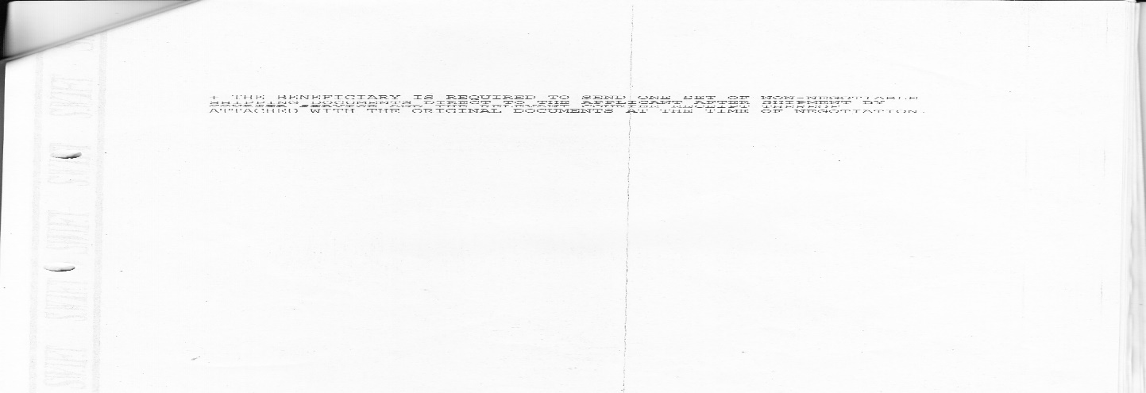

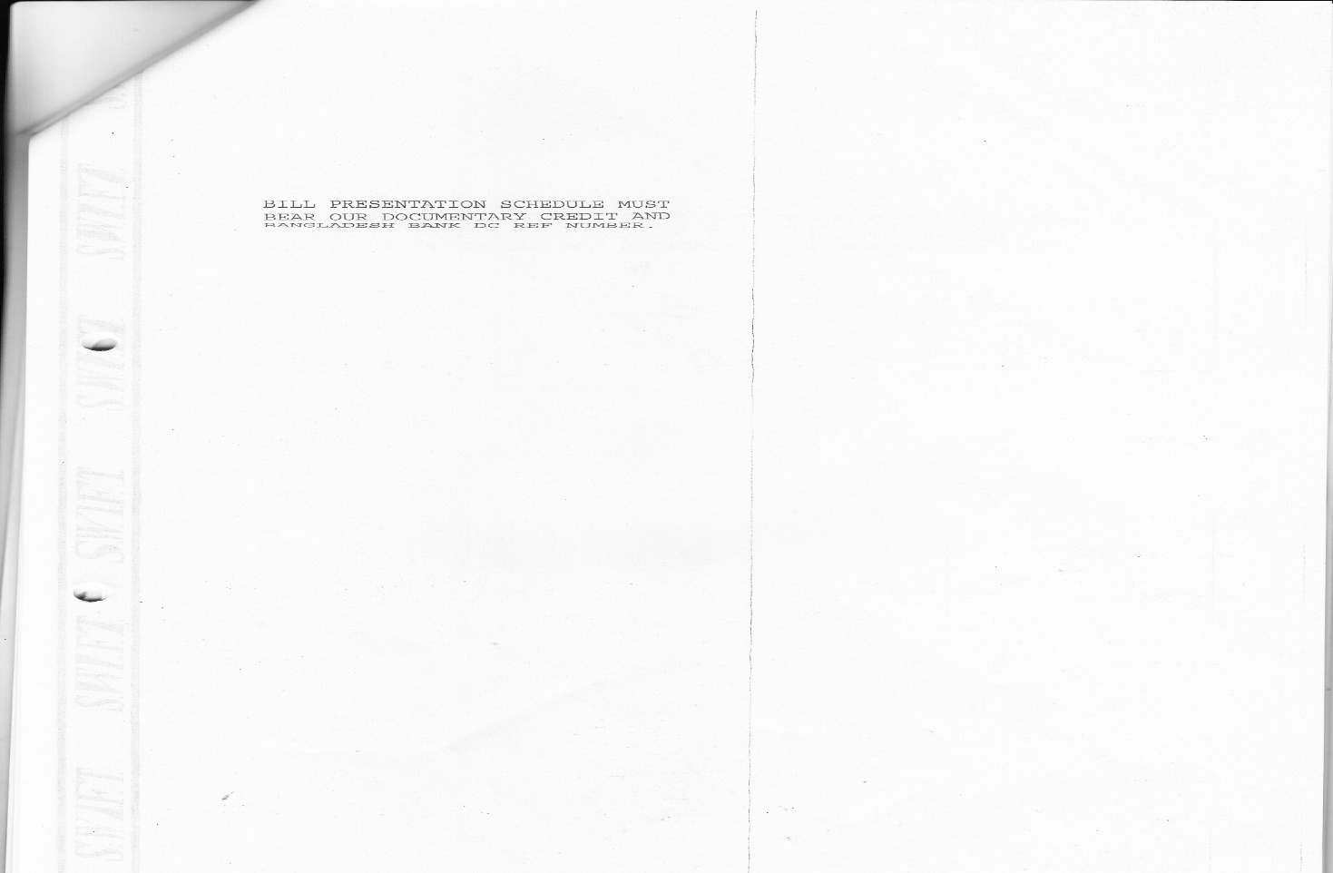

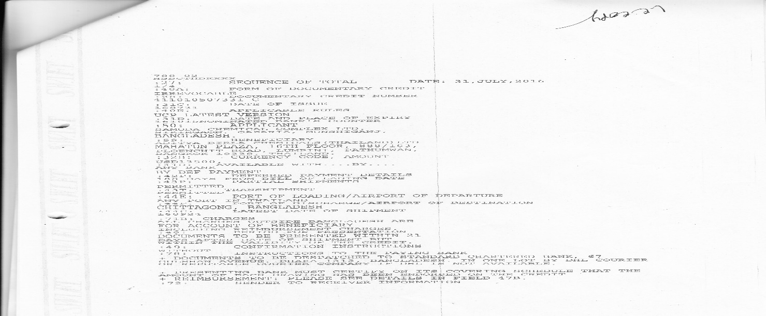

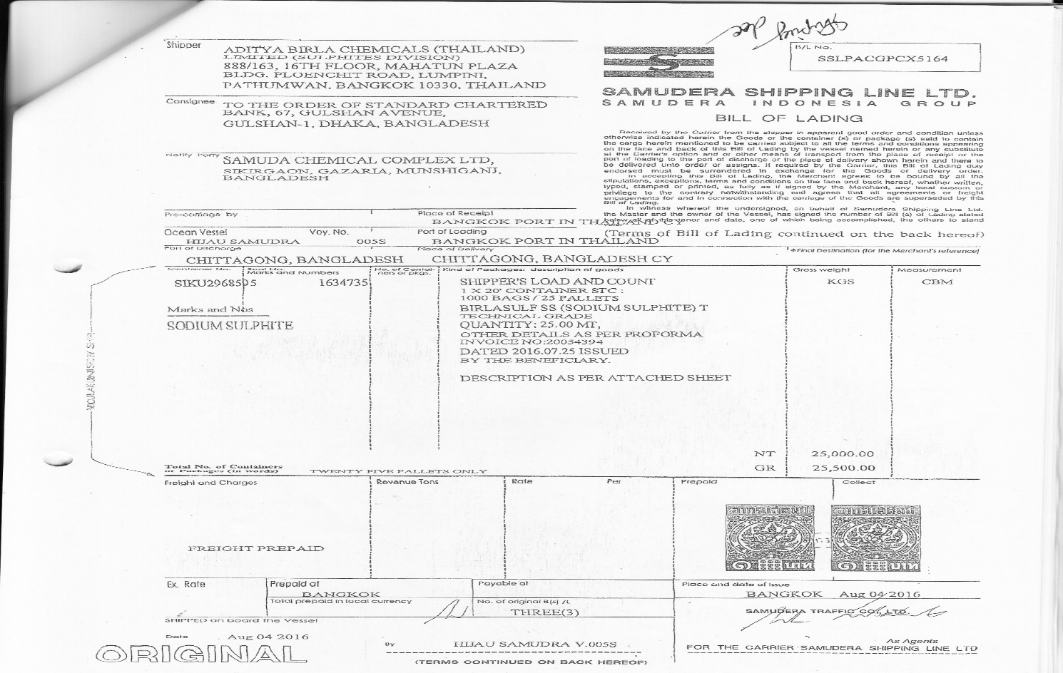

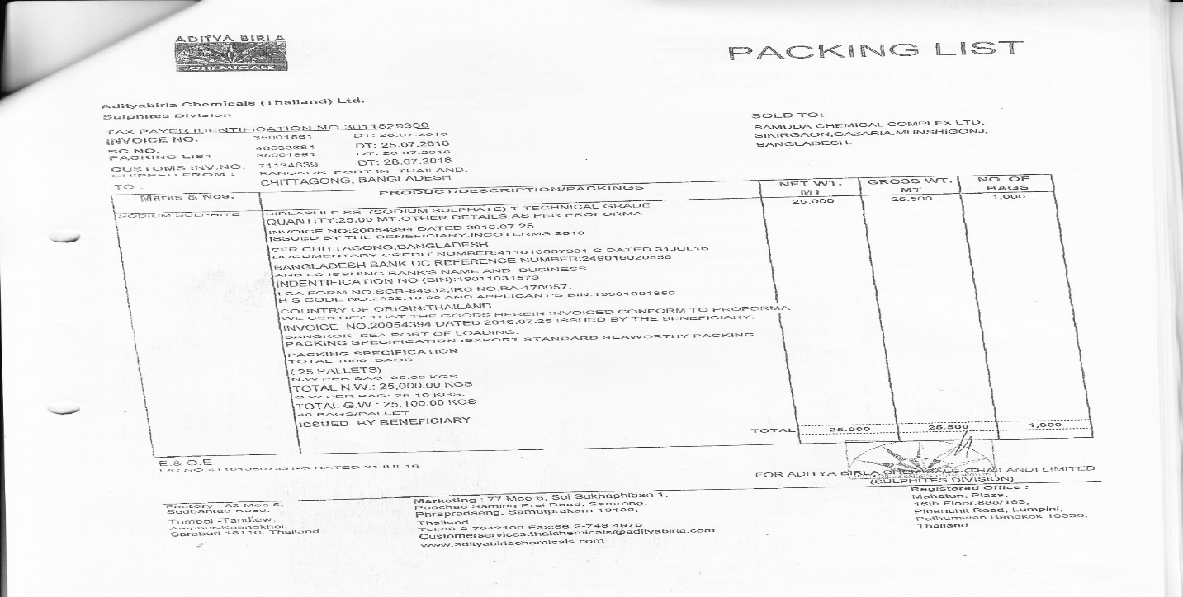



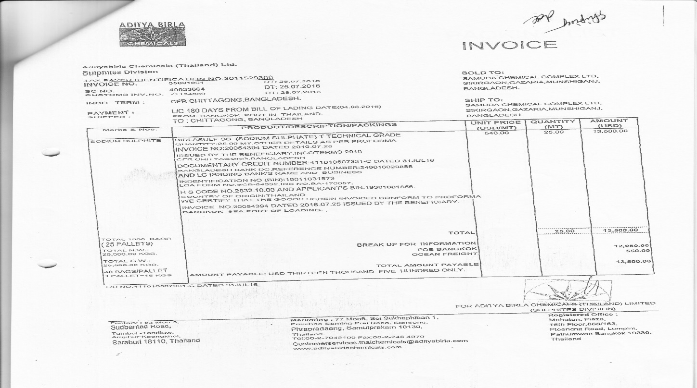

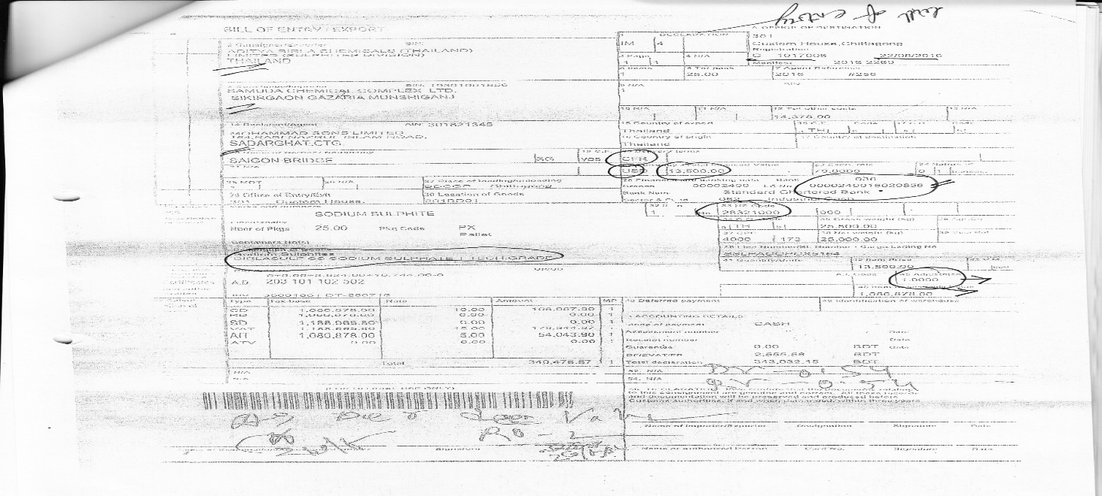

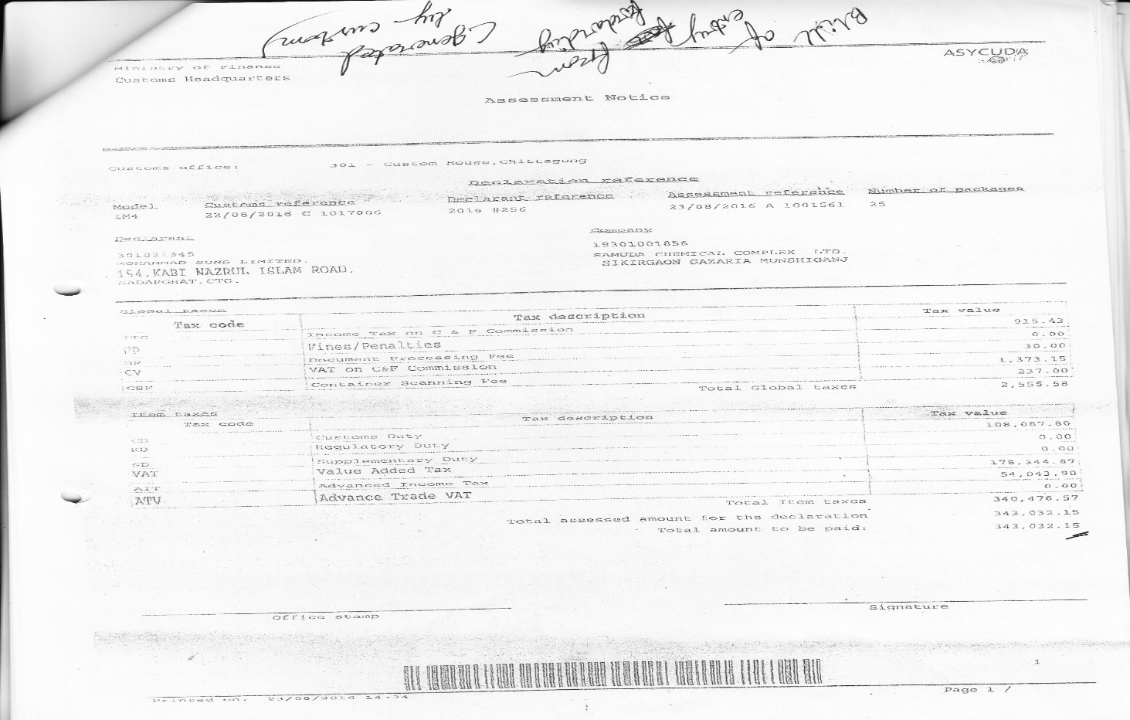

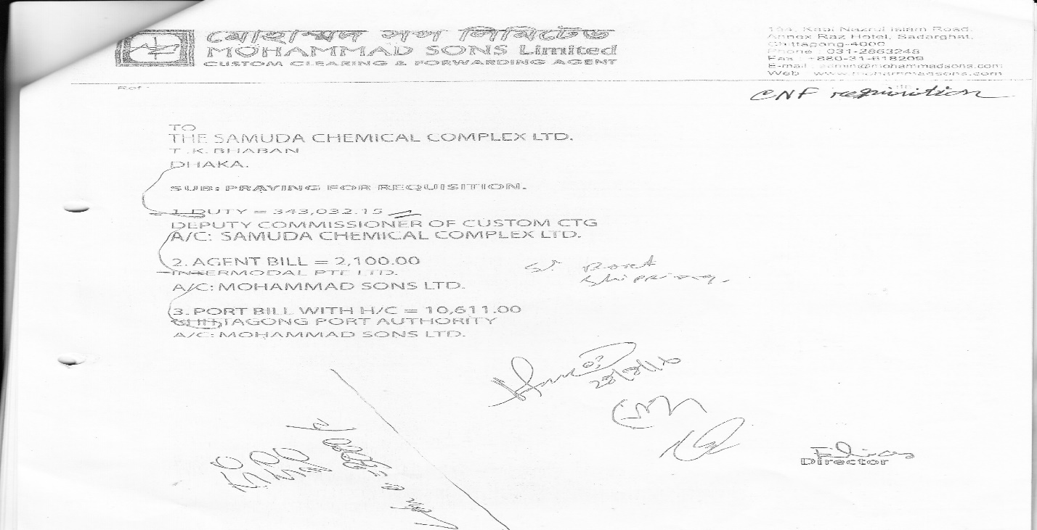

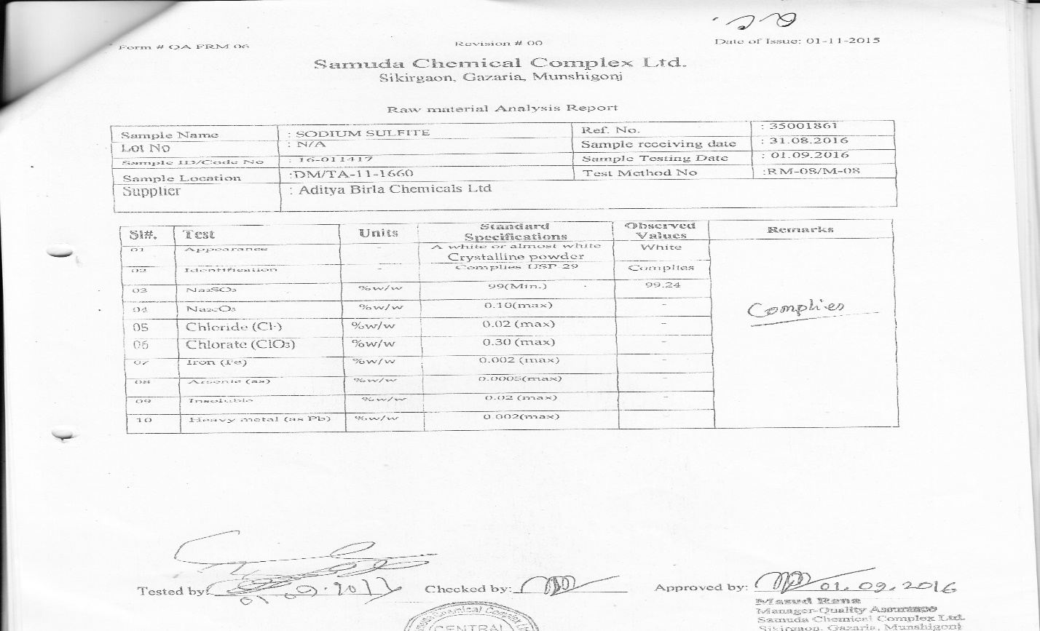

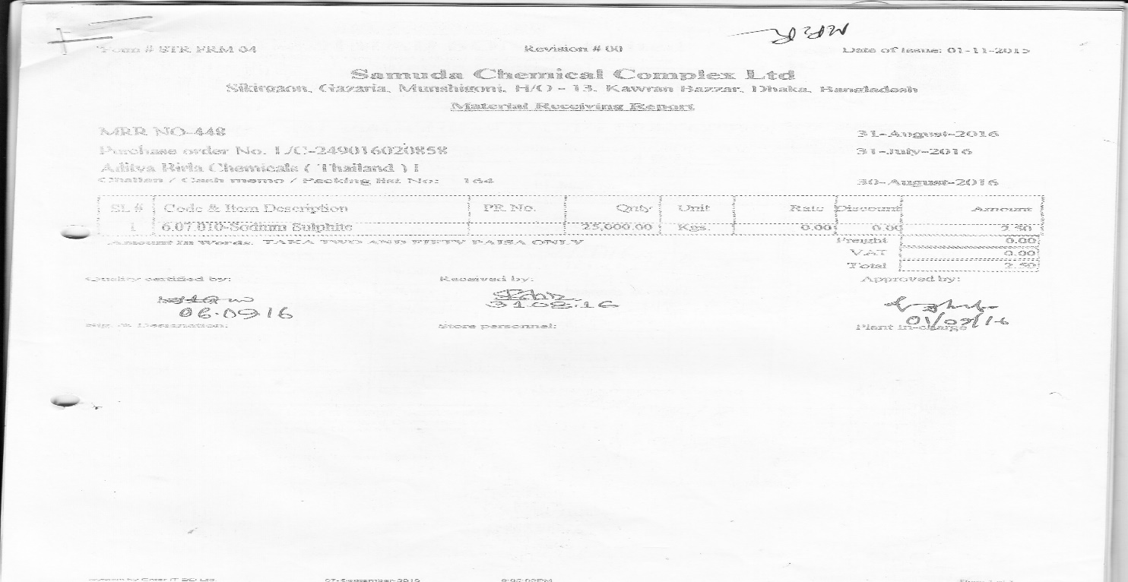

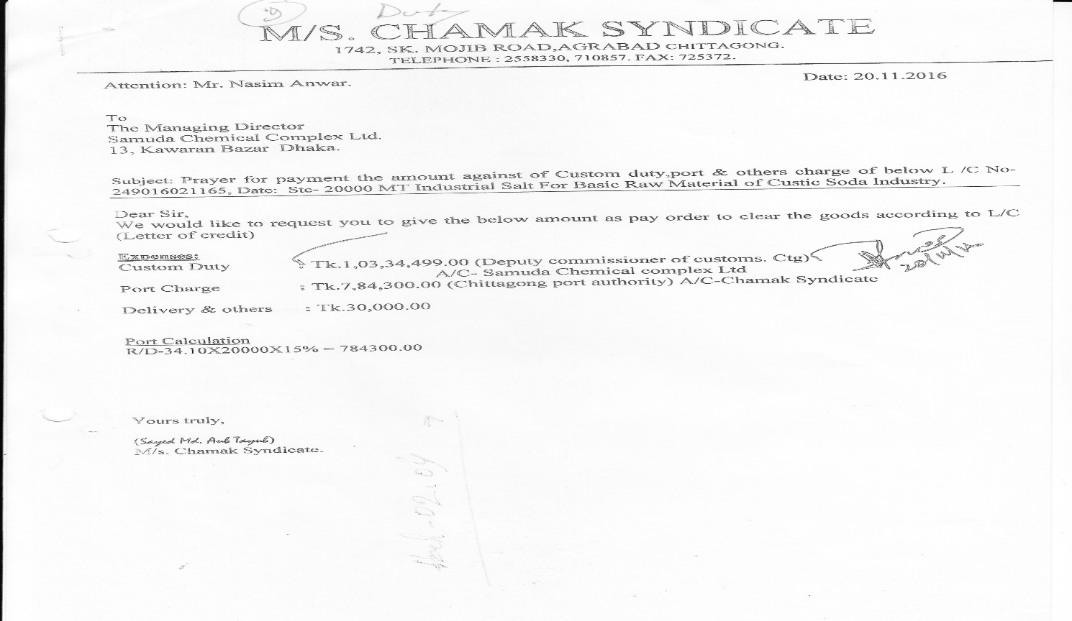

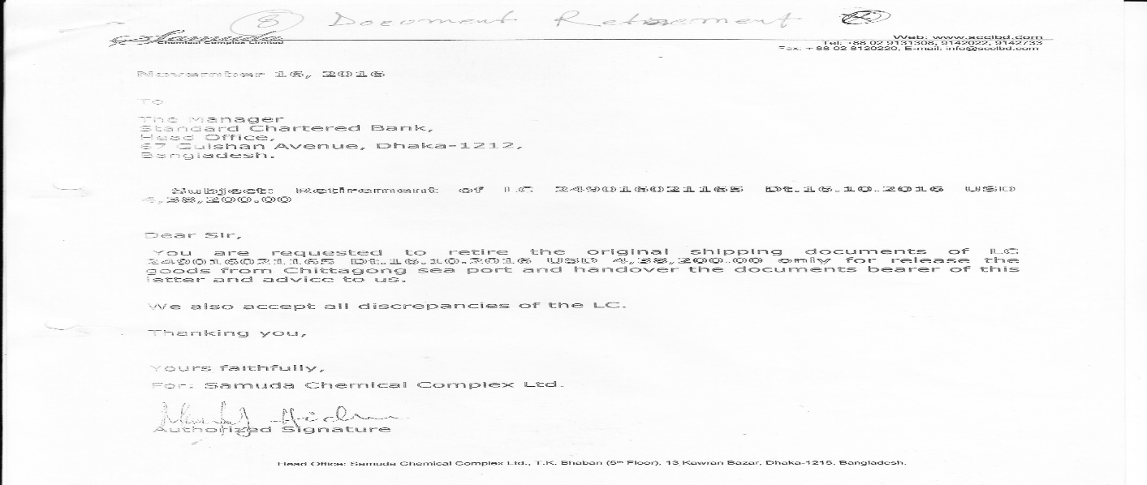

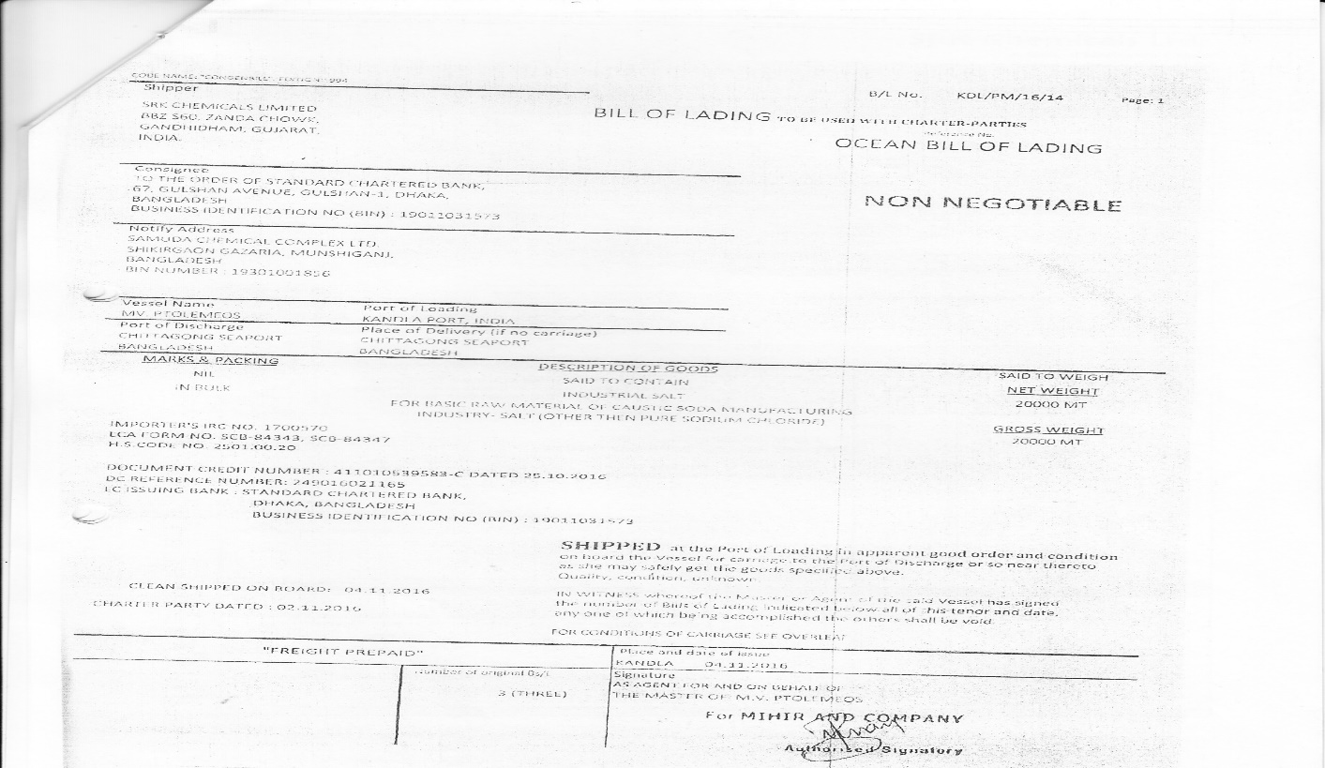

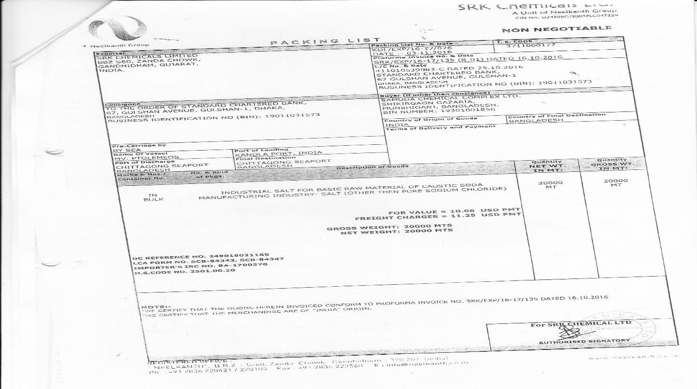

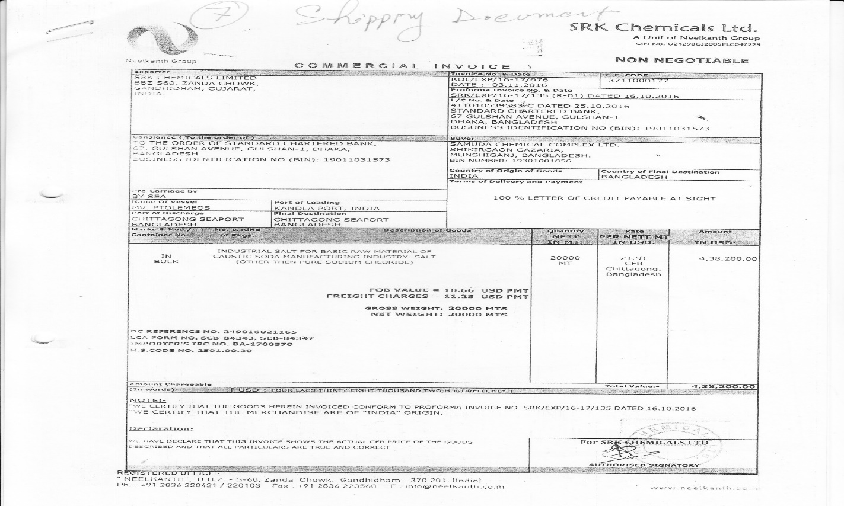

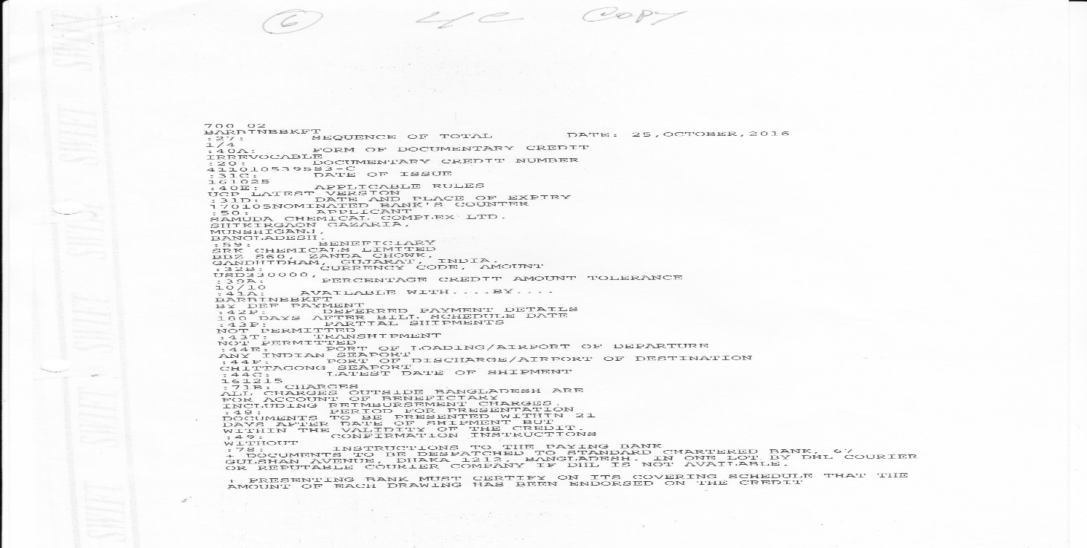

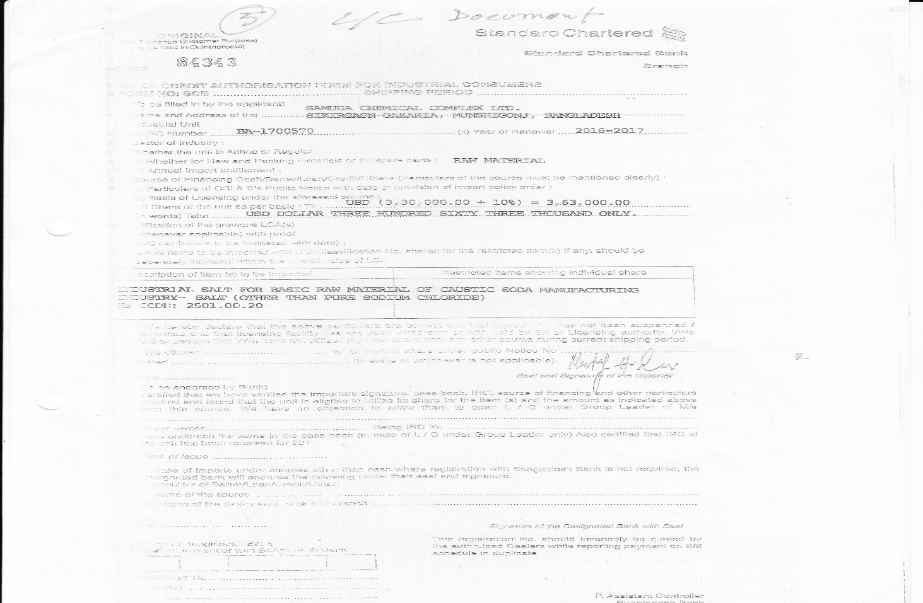

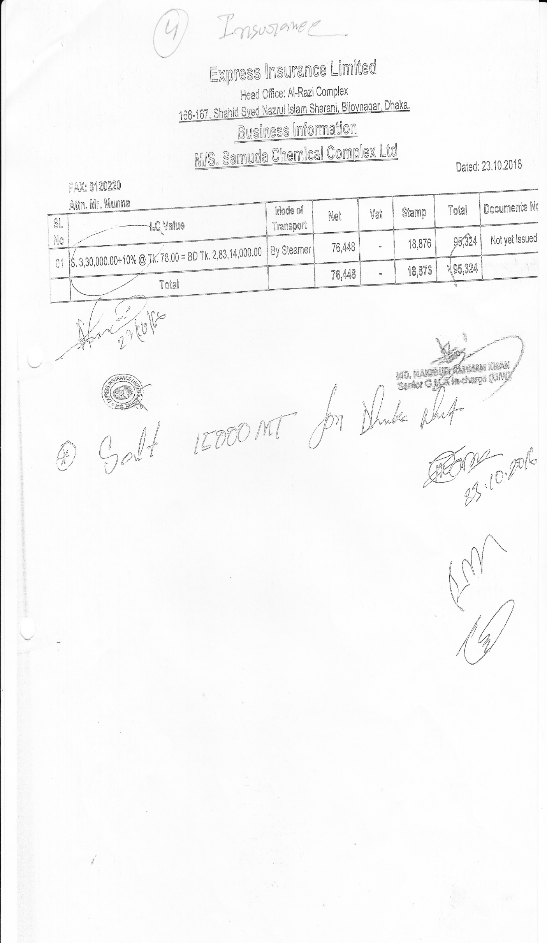

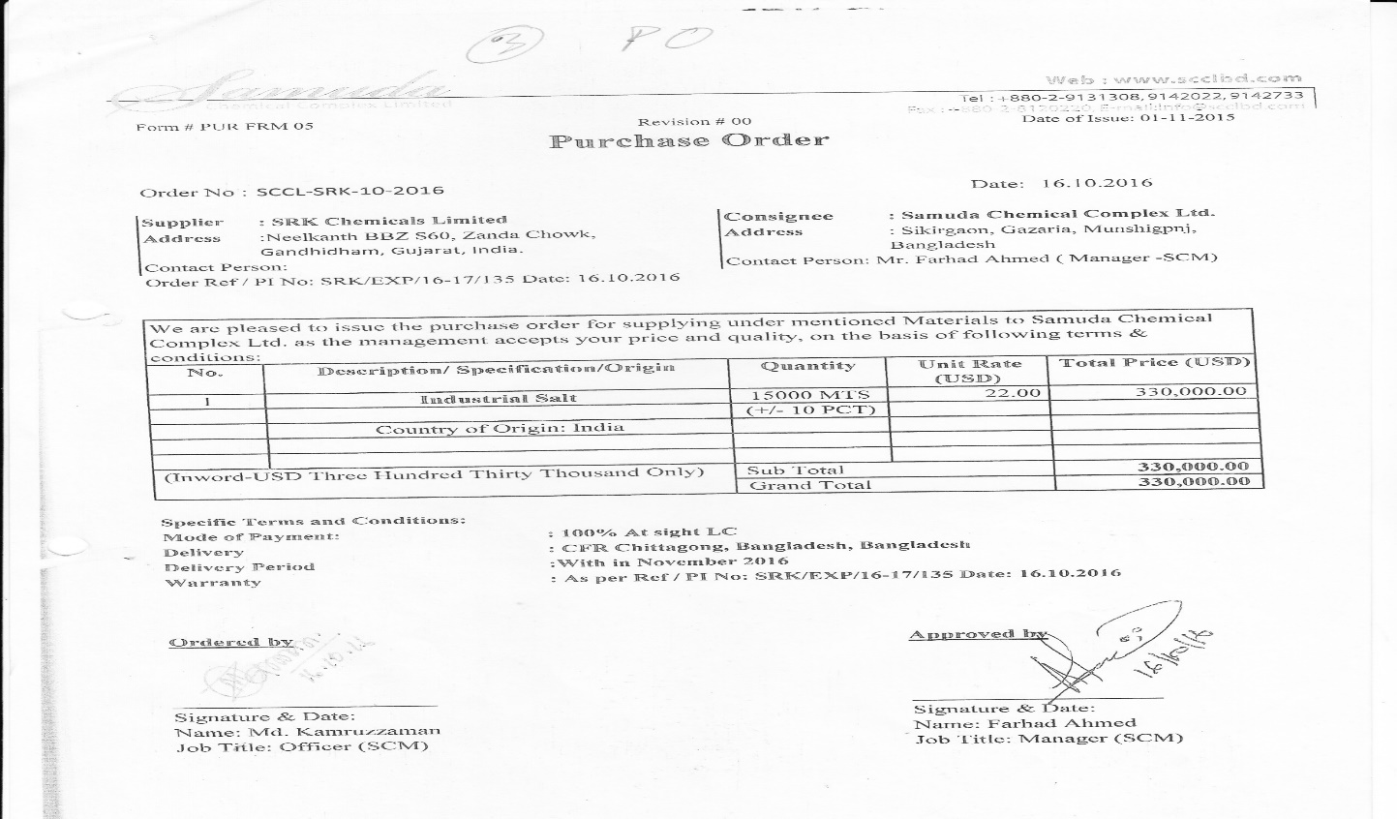

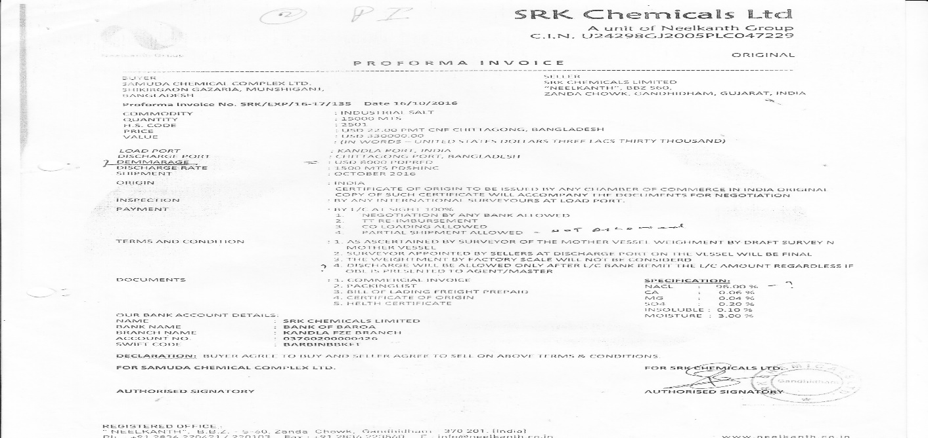

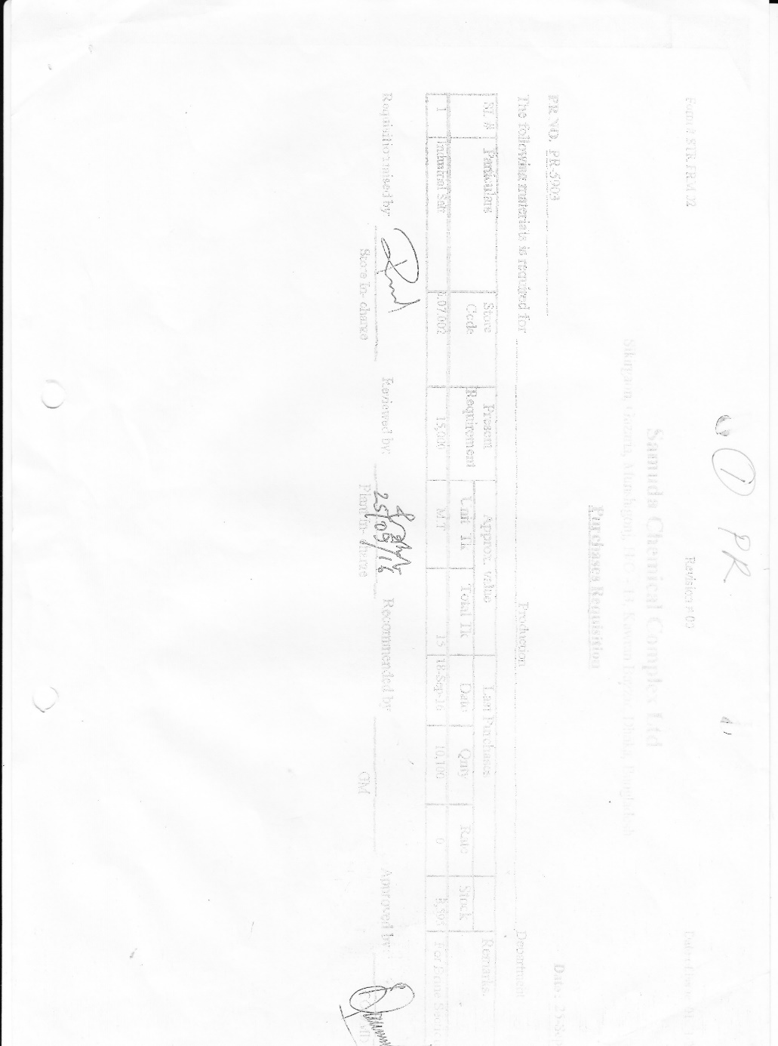

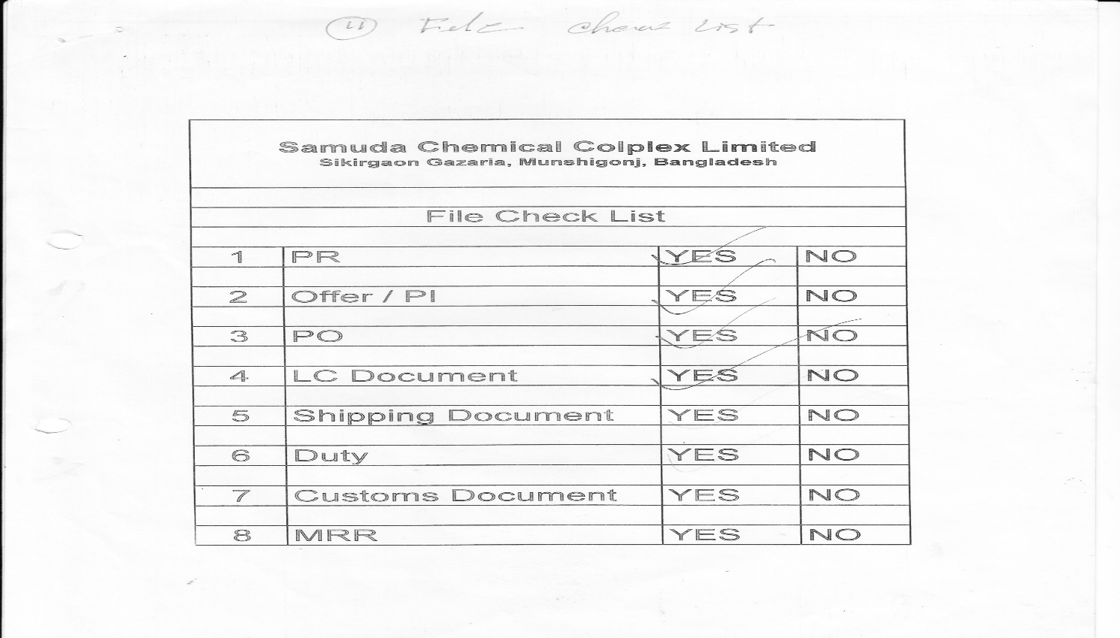

# **5. To be Determined**

1. ISO 9001 related reports are not implemented within this phase. We will cover in next phase.

Signed on behalf of Signed on behalf of

Samuda Chemicals Ltd. Genweb2 Limited

Name: Name:

Designation: Designation:

Date: Date:

**______________________________ ______________________________**

Signature Signature